CCHS OLD GIRLS’/ALUMNAE ASSOCIATION
NEWSLETTER – Spring 2025

Editor’s Notes
Quite a thick Newsletter this time as we have the 2024 AGM Minutes and our usual printer having moved from the area, many thanks to the CCHS Reprographics department for printing it for us! Thank you also to everyone who has sent in articles, poems, etc, and once again to Joan Gurney who has written an article, about the Antiques Roadshow. Old Girls also enjoy reading others memories of CCHS so please keep them coming! I do trawl through old School Magazines for interesting bits, but it’s not the same as members writing in now! It is not difficult to email me (or call me for my postal address) and I reiterate that no great literary work is required! I hope you can come to the many events that Jean Johnson is organising this year. Details of our Colchester events and the relevant reply slips are at the end of this newsletter.

Contact details: Liz White: Tel: 01206 522713 e-mail: alangwhite187444@hotmail.com

Information, news, comments, photos and articles for the next Newsletter by 30th September 2025.

PLEASE LOOK AT EVENTS ON PAGE 13 – reply slips on pages 15 and 16.

COLCHESTER COUNTY HIGH SCHOOL FOR GIRLS
OLD GIRLS/ALUMNAE ASSOCIATION
ANNUAL GENERAL MEETING CCHS DINING ROOM, NORMAN WAY, COLCHESTER
27 JULY 2024, 11am

Meeting preceded by tea/coffee and biscuits.

In attendance – 19 members and Kate Stubbs of CCHSG

- APOLOGIES
Jenny Crewdson, Jennifer Pennick, Jane McMillan, Vivienne Springett

- MINUTES OF THE LAST AGM AND MATTERS ARISING
Minutes of the last AGM have been provided to members in the newsletters sent out earlier this year. Monica pointed out that under item 11. Any other AGM Business, Vivien’s daughter is Ruth Baldry, not Rue. She also advised that she did not agree to write a piece for inclusion in a future Newsletter. There were no other comments or matters arising and the 2023 minutes were agreed by a show of hands of all present. Mary signed these minutes on behalf of Liz, who has broken her wrist.

2. CHAIR’S REPORT – Liz White
All relevant matters have been covered in Jo’s report (see below).

3. SECRETARY’S REPORT – Jo Edwards
Well, to misquote a misquotation, rumours of our demise have been greatly exaggerated! We have actually had another good year. All things are, of course, relative! We will never achieve the extraordinary success of the Grammar School’s Old Colcestrians or Chelmsford’s King Edward VI Grammar School’s Old Chelmsfordians but we soldier on. Did you know that the Old Chelmsfordians have a superb social centre with function rooms, bars, professional kitchens, etc, plus enormous playing fields? How the other half live! I digress. It is, however, with some relief, that I can report that the School’s new networking platform, CCHSG Connect is proving very successful and will provide an excellent way of keeping OGA in touch with the School and each other. I will leave Kate to explain in more detail. Last year, we discussed the possibility of a memories project. Again, I will leave Kate to report back.

We have had several events this year. The first following last year’s AGM was, of course, the Garden Party in Liz’s garden. It was, as always, a wonderful afternoon. I do love people watching and sitting quietly enjoying the reactions to the array of gorgeous cakes always amuses me, as does Jean’s face when the sausage rolls appear! The Garden Party was followed, a few weeks later, by our customary Coffee Morning at Greyfriars. Then, in the Spring, we returned the Officer’s Club for another Coffee Morning with cakes, which was particularly well attended. We did, of course, have our Chinese Lunch at the Bamboo House. The food just kept coming but there wasn’t a lot left at the end! We slotted in a new event, Breakfast at the Lexden Crown on a Saturday morning. We will be going again very soon!! We must, as usual, thank Jean for arranging all these events as well as keeping us financially on the straight and narrow. She does an amazing job. We must also thank Liz for catering for us, both at the Garden Party and here at the AGM. This year, things might be a little different because of her broken wrist but she wasn’t going to be fazed by such a ‘minor’ inconvenience. We will still have lunch today and afternoon tea at the Garden Party! Di and Alan, Liz’s husband, are, as always, helping and Committee members, too. We thank them all. Liz, of course, chairs our meetings.

Committee meetings are usually held at Jean’s and are ALWAYS huge fun. Mary takes amazing Minutes and also deals with the School Leaving Award Fund. Tina is our Membership Secretary and looks after our social media. Thanks, both of you! Kate comes to as many Committee meetings as she can for which we are really grateful. She is so good at keeping us in touch with everything that is happening at the School. We are SO lucky to have her. If I send an email to her I can absolutely guarantee that I will receive an immediate answer with a full, detailed, response to my questions. She is the reason we are back here at the School for our AGM. She made the arrangements for us! We really appreciate all you do for us, Kate.

Thank you. Liz, as our Newsletter Editor, tries to include news of the School in each edition. Very sadly. the next Newsletter will carry the report of the unexpected death of Latin and Classics teacher, Beverly Hodgkinson, who had taught at the School for over 40 years. She will be remembered with affection by generations of Old Girls. Liz has produced two Newsletters this year. She relies on copy from Old Girls, so, if you have memories, news of Old Girls, information about reunions etc etc, please let Liz have them. Contributions for the next Newsletter should be with Liz by the 30th September but if you miss this deadline, don’t worry, your contribution will go into the next. We would particularly welcome contributions from our much younger members.

Speaking of reunions, please let us know if you are having one for members of your year group. We might even be able to help with tracing some of your old form mates as long as you give us a bit of warning. Liz attended the Leavers’ Assembly to present the School Leaving Award to Megan Gray Cullem. This is an occasion that Liz really enjoys. It is good to be able to wish those leaving girls the best of luck for the future and to encourage them to follow their dreams. This year’s exam results are not yet available but, if they are like last year’s, they will be quite extraordinary and we can all say, yet again, I went to that school!!

3. TREASURER’S REPORT, 2022–2023 Accounts – Jean Johnson
Copies of the accounts have been passed around (and are appended). Although our funds are getting lower, we have only had to transfer £100 from our Saver A/c this year to tide us over until fees could be collected and deposited. This year the cost of all our events has been covered by the money collected for that specific event. We continued not subsidising the Greyfriars Coffee Morning so we didn’t lose money and as the price of £10 didn’t affect the numbers attending we will acknowledge that members are only too happy to return to Greyfriars regardless of the price. You will see the corresponding figures in the Income and Expenditure columns don’t always correlate. This is because we offer events for the year, but our accounts are written from end of June to the beginning of July the next year. Although your Committee made a decision several years ago to offer the newsletter free to all members over 80 who wished to receive a printed copy, this decision has somewhat been overtaken by inflation. We will, therefore, be adding a note to the next newsletter to appeal for assistance to our OGA funds, hopefully to receive donations from our not so local members. As last year, can I appeal, as the School Leaving Fund is in a healthier state than our Association funds, that any money donated today can be taken by the OGA Treasurer rather than the School Leaving Fund Treasurer! No questions were raised by members.

5. OGA MEMBERSHIP AND WEBSITE – Tina Powell
Although we have both of the above, we are finding that the younger members tend to access news of their fellow students via social media or the School website, rather than through the OGA’s resources. Technically, all new leavers automatically become members of the OGA. Comments - Monica has forwarded to Jo details of two people from her village who are eligible OGA members.

6. SCHOOL LEAVING AWARD 2023/24 – Mary Softley (Rickard)
Every year, the School is asked to nominate a student who has made extra effort outside their studies, or has who supported fellow students, overcome personal difficulties, or displayed some similar qualities of merit – this is not an academic achievement award. The Association currently awards £100 to the chosen student, presented by Liz White at their end-of-year Leavers’ Assembly. This year, the School chose Megan Gray-Cullum. She was nominated in acknowledgement of her many contributions to the school community, citing in particular: her sustained and wide-ranging contributions to the school societies, such as Law Society and Debating Society. She has undergone significant challenges over the last few years, but faced them with positivity and strength, providing an inspiration for others. Megan will be reading Law at Cambridge University in September. Megan has sent the Association a lovely letter of thanks:

“I would like to say a huge thank you to the OGA for awarding me the OGA’s leavers award as I feel truly privileged to have been awarded this. The last two years for me have been a whirlwind to say the least but the community of CCHSG and support of the school has been instrumental in making me the person I am today. I am so grateful to become part of the Old Girls Alumni and continue being part of the community. Once again, I am truly appreciative for the award and would love to keep in touch with the OGA in the future. Thank you, Megan, “

Thanks to the much-missed Pauline Millatt’s bequest, the School Leaving Fund is now looking much healthier, and we will be able to continue to reward worthy students like Megan for quite a few more years. As of 7th June 2024, the School Leaving Fund sits at £2050.52.

7. REPORT FROM THE SCHOOL
Presented by Kate Stubbs, Marketing & Communications Manager, CCHSG
Firstly on behalf of the school I would like to thank the OGA for continuing to present the Leaver’s Award and to Liz for speaking at the Leaver’s Assembly and making the presentation.

This has been another busy and successful year here at CCHSG. Ofsted In January we were visited by Ofsted to undertake the first inspection of the school in some 14 years. The inspection found CCHSG to be an exceptional school and outstanding in every aspect, with no areas for improvement. The school continues to be heavily oversubscribed. There are 6 forms of entry, with 192 students in each Year Group from Year 7 to Year 11 totalling 960 in the lower school. The Sixth Form has around 240 students. Places at CCHSG continue to be applied for through the Local Education Authority and allocated to students based on performance in the 11+ selection test. The test is administered by the Consortium of Selective Schools in Essex, CSSE, allowing students who may wish to apply for several selective schools, to take one centralised test. The test is hosted here at CCHSG on a Saturday in September each year with 3 sittings, one kindly hosted by St Benedict’s, for some 600 students, across the day. The changes to the admissions policy come into force for the next intake of students (Sept 2025). The allocation of places is quite complex with particular access arrangements for students who qualify for free school meals, pupil premium payments or Service Pupil Premium, due to a parent being in the armed forces. There is now a priority area of 25 miles, which applies to 154 of the places. The remaining 38 places are then allocated in descending order from the Rank Order of Merit List, highest scoring first, regardless of where the girls live. The full policy is available to read on the website. https://www.cchsg.com/admissions/year-7-admissions/

Languages are an expanding area of the curriculum, with Spanish newly introduced in Year 7 and Chinese available as an additional option. This year we will have French, Spanish, German and Chinese language assistants, in school to work with students. This is organised through the British Council. Colchester Teacher Training Consortium You may be aware that we are the lead school for the Colchester Teacher Training Consortium, which operates from the training centre on our site. CTTC annually trains around 80 primary and secondary teachers to achieve Qualified Teacher Status (QST). Trainees combine classroom-based learning with school experience alongside colleagues in one of the many local schools who form the training consortium. Many of the trainees go on to be employed in consortium schools. CTTC was also inspected by Ofsted in June this year – and the provision was found to be outstanding.

Past Students: The school is keen to involve past students in our careers programme, to support students with their progression post-18 and potentially as mentors for current students. For the past year we have been working with education charity Future First who have helped us to set up an online platform that we call CCHSG Connect. We also have a CCHSG Connect LinkedIn page. This has been reasonably successful, with around 250 past students now signed up to be involved. A very successful progression day was held on 1 July with 8 past students who are now working in a variety of fields hosting a morning of progression workshops for Year 10 and Year 12 students. Alumni also came back to contribute to Oxbridge advice sessions and give lunchtime talks to the student run Medical Society. We are also inviting alumni to feature on progression posters, outlining their pathways since CCHSG. These will be displayed around the school from September. Members of the OGA are very welcome to participate and I will be forwarding information for the next newsletter.

CCHSG Archive The school is keen to curate and share the historic CCHSG archive. I have collated all the materials that could be found in school. I would also like to thank members of the OGA who have donated additional items in recent years. We now have a substantial and complete collection of year books and various other items which will ultimately be digitised and shared online. The “History of CCHSG” section of the website is expanding all the time, with the aim of having the majority of the existing materials on the site over the next academic year. https://www.cchsg.com/about-cchsg/history-of-cchsg/ 20 Year Group photos from 1920 onwards have been digitised and are now on the website. The intention is to display these photos in the main school hall, alongside the honours board. I have displayed some of the archive materials and photos – if you have not yet had a look – please do.

Comments - Liz and members present were pleased to hear that the school catchment criteria were being adjusted to favour more local students. Monica asked if the 25-mile catchment included Southend. Kate thought not and advised that the radius is strictly drawn and adhered to. Monica has provided Kate with a few items for the school’s archive. She has been busy with her own memories project but has carried out 3 recordings of memories with Old Girls, including talking about how they travelled to school, and about their mothers. Monica is happy to share these recordings with the school. She has also put together a consent/copyright form, signed by participants: Monica is willing to share this with Kate in case it is of use in relation to the school’s archive project.

8. MOTIONS - None received.

9. ELECTION OF OFFICERS - There were no new nominations or expressions of interest. The existing Officers confirmed that they were willing to stand in their current posts for another year.

CHAIR – LIZ WHITE (BAILEY) (1960-66)
SECRETARY – JO EDWARDS (MABBITT) (1960-68)
TREASURER – JEAN JOHNSON (CUTHEW) (1951-56)
COMMITTEE – TINA POWELL (1968-75), MARY SOFTLEY (RICKARD) (1969-76)

This was unanimously agreed by show of hands from all present. The members present thanked the committee for all their hard work over the last year.

10. ANY OTHER AGM BUSINESS No matters raised.

11. DATE AND VENUE FOR THE 2025 AGM
It was agreed that the committee would discuss suitable options at their next meeting and agree a final date with the School. Members will then be notified. All present thanked Liz and Di for all their hard work preparing such a delicious lunch, especially Liz, given that she had recently broken her wrist (and despite the ‘assistance’ from various committee members!).

Signed by (Chair): Dated: 27th July 2024

Jo Edwards (Mabbitt 1960-67)
﻿

‘Mum, Father Christmas wants to know what you would like in your stocking this year.’
As grandmother to two young children, Jimmy (7) and Molly (4), I always find that Father Christmas has left presents for me, too, when I join the family at some unearthly hour on Christmas mornings. My son reminds me in early December that I need to write my letter, ready to be set alight in their garden fire pit, the sparks winging their way to Lapland - or is it still the North Pole? I think Father Christmas may have moved his HQ since I was a child!

In the Autumn, I saw a small print of some nasturtiums and immediately added it to my list. It was incredibly evocative, so much so that it almost reduced me to tears. I was transported back to the Spring of 1962. Molly Brown was my form mistress. Molly was something else! Inspirational, outspoken, bursting with enthusiasm - an outstanding art teacher, but a complete maverick. Her dyed black hair was always casually pulled back from her face and into a wayward ‘up style’. Heavily made up with a dark foundation and lipstick that was as wayward as her hair, her appearance was unusual but, strangely, completely right. Her clothes were stylish and usually aubergine in colour. She wore gold winkle picker stilettos. Fishnet tights often completed the look as did heavy gold jewellery. Molly was a one off.

It was during afternoon registration, normally an opportunity for her to insist on us reciting the Greek alphabet (I can still do so) that she asked us whether any of us had nasturtiums growing in our gardens at home. I did. They were self sown and grew vigorously in the west facing border beneath an ancient brick wall. Molly beamed at me. The following day, she gave me a sealed envelope with instructions to give it to my mother. My mother replied to her letter, giving it to me in another sealed envelope to pass back to Molly. No explanation was forthcoming. Nothing happened until June when I was given another sealed envelope for my mother and returned the following day with one from her to Molly. A week later, my mother got up much earlier than usual and went out into the garden to pick all the nasturtiums she could find, both fully out and buds, plus a lot of leaves. These were gently placed into a massive carrier bag. I was told to go to school early and take the bag straight to Molly’s Art Room. Taking such fragile stems as well as my satchel on a crowded bus was interesting but I managed it. Molly was over the moon. It was the O level Art exam day and every entrant had to produce a drawing of nasturtiums. Horrendous! Two years later, it was my turn. I went to school that morning with another huge carrier bag filled with nasturtiums. I took my Art O level a year early and did very well. Did I have an unfair advantage? Possibly, but it was actually my weaving that produced the high mark - a maroon mohair scarf with an orange stripe running through it. Molly and I decided on this unlikely colour combination together and it worked. I still have the scarf. It was very warm but the mohair really irritated my skin. Such a shame.
Nasturtiums always remind me of Molly and those summer schooldays. Father Christmas granted my wish. The print is now on my wall and I love it.
Joan Gurney (Appleton 1938-51)
The Antiques Roadshow

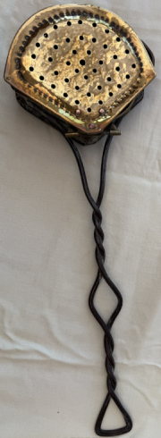
How do you become so attached to antiques that every Sunday evening for decades a television programme keeps you fixed in your chair for one hour?

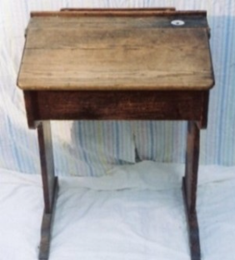
In my childhood, the farmhouse in Dedham where I lived with my parents was crammed with what was considered ordinary farmhouse furniture, decorative pieces and useful objects needed for everyday jobs. These included dark coloured oak furniture, copper kettles, butter churns, scrub-top tables, bedroom washing jugs and basins and chestnut roaster. (left)

When I went to the Preparatory Department of CCHS at Grey Friars, my surroundings were similar. I sat at a desk of dark stained wood (right) which had an atlas rack at the front and an inset ceramic ink well on the right hand corner which adjoined a long shallow groove for pens and pencils.
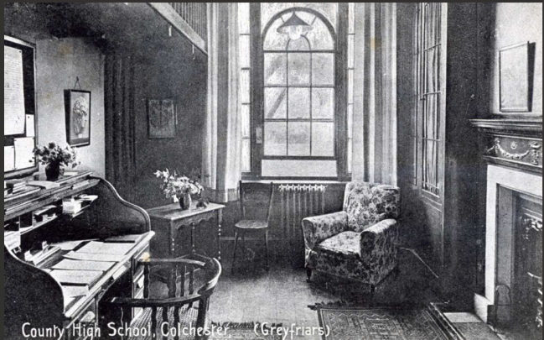
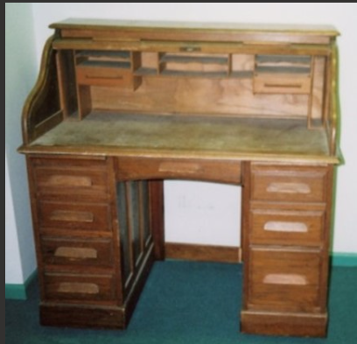
If you were ever sent to the fierce headmistress (Miss King) for bad behaviour, you would visit her study in the former beautiful library (left) at Grey Friars where she sat on a wooden armchair at her roll-top desk (right) and brought fear into you before she even spoke. Other pieces of imposing furniture and the overhead gallery laden with books also added to the oppressive atmosphere.

So what is an antique? In my childhood it was considered to be an object which exceeded 100 years old, but over the years this has proved to be a ‘moveable feast’, and objects which were once in every home are now considered collectable. I left CCHS in 1951, went to university, taught in several secondary schools, married and had a family and during this time television had firmly established itself as a replacement for the radio which had been the main form of evening entertainment. Different programmes came and went; some lasted for a short time, others for longer, then, 26 years after I had left school and had said goodbye to my old school furniture and the objects of my parents’ farmhouse, the BBC started a bold new venture in programmes.

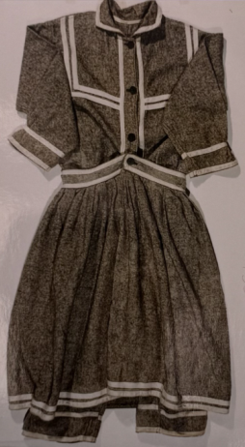
On May 17th 1977 a team of experts from the world of antiques gathered together in Hereford Town Hall to take part in an experimental programme called The Antiques Roadshow. None of them knew what to expect. The public had been invited to bring along ‘old’ objects and have them assessed and valued – but who would come and what would they bring? Nobody, however, needed to have worried about its success. The months grew into years and the years into decades, until in 2 years time the Antiques Roadshow will have reached half a century.

I was captivated from the very start, and Sunday evening was not complete without the Antiques Roadshow. The first presenter was Bruce Parker and, as the years rolled by, we saw Arthur Negus, Angela Rippon, Hugh Scully, Michael Aspel and then in the present day Fiona Bruce. Old familiar faces in the team of expert valuers often kept going for years. But viewing the programme on television for me was not sufficient. I had to visit a live filming.

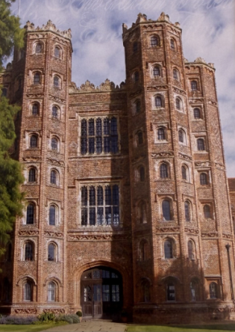
In 1994 the Antiques Roadshow was due to come to Colchester Sports Centre at Charter Hall. It was difficult to believe that it was 17 years since its first appearance, and it was still quite often filmed indoors. What should I take? After much thought, I decided to take an early item form my Bathing Bygones Collection – a 1890s lady’s bathing dress (left) - and my husband, Gerald, would take a piece from his Rackets Collection – a Lazy Susan dining table centre piece decorated with tennis rackets. Both our pieces were selected as ‘interesting’ and we were put aside to be filmed again later for possible inclusion in the live television programme. There was no disappointment in not being selected from this final group to appear on screen because the whole day had been an extraordinary and enjoyable experience.
I had dipped my toe into this extraordinary world of antiques so why not do it again? The programme was so successful that it was nearing its 20th anniversary in 1997 and before and after that date whenever there was a Roadshow day in the locality I would be there with an item. I went to Layer Marney Tower (right),

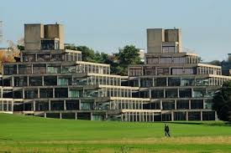
Wimbledon Lawn Tennis Club, Lords Cricket Ground, the Sainsbury Centre at the University of East Anglia (left) and Helmingham Hall.

The pattern of the filming day had expanded and developed, so that historic buildings, modern architectural gems, sports facilities, seaside complexes, museums, galleries and universities - all of which might have extensive grounds – were used and much of the filming took place outside.


Teams of engineers, lighting directors, designers, producers, technicians and many others were involved in the weeks and days before, and after the event itself. The recording, of course, was at the centre of things (right).

In my experience, a visit to the Antiques Roadshow filming day is an enjoyable day, and a template in co-ordination where you can meet other people interested in old things, and perhaps even take your dog and your children.

You are met at the entrance and directed to the Reception Point where your object is examined and you are directed to the appropriate specialist where you join a queue which leads to you meeting and talking to the expert who will assess what you have brought. If the object is of special interest, or has an intriguing story surrounding it, you will be put in reserve and seen again later. Nothing is rehearsed. Everything is very relaxed, informal and jovial. Most of the filming is completed outside and the grounds are dotted with large colourful umbrellas which shelter the expert, his or her table and you, the visitor. Precautions for bad weather include use of indoor facilities and extra marquees.

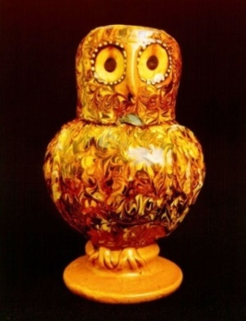
In the early days of the Antiques Roadshow very large pieces of furniture were often brought, but over the years absolutely anything can appear, large or small, inherited possessions, gifts, items dug up in the garden, found in scrap yards, purchased from antique shops, charity shops and boot fairs. Everybody who has entered the complex by closing time is seen. Some valuations are eye-watering and some items rare, simple or unique. Everybody remembers Ozzy the Owl left) from past shows – a very early simple drinking pot from the past and used by its owner as a flower vase. A new language of antiques started to evolve = ceramics, memorabilia, and militaria. Gerald and I invented our own to cover our Collections – racetana and swimmerabilia!

By 2007 the Antiques Roadshow had reached its extraordinary 30th year. Items brought in now included not only those previously classed as antiques, but those from the 20th century including autographs, first edition books, clothing, sports equipment and other belongings from ‘Pop’ groups, designers and famous and notorious people. Really valuable items reached unimaginable estimates. Jewellery often topped the list, but many of the owners of the most valuable items said that they would never sell them because of their sentimental value. It was always interesting, however, to hear news in later television shows of the destiny of some items, and the prices raised by those which had been sold.

In 2024, once again Colchester featured as the venue for the Antiques Roadshow exactly 30 years since the last visit to the town in 1994 – now a city. This time its site was Firstsite, the relatively new art gallery built in the intervening years. The visit did not have as much advance publicity as it did on the previous occasion, but three television viewings resulted from it and one or two visitors’ items reached high estimates from the experts.

But the show had suffered a serious change to its production and format caused by the limitations imposed during the Covid lockdown. Restrictions on close contact, movement, meetings, gatherings and the wearing of masks were enforced. It was always hoped that these restrictions affecting the Antiques Roadshow would eventually be lifted, but even today, if you have an object to take to the Roadshow filming, you must make contact beforehand with a description and image of it, together with a story - if it has one – and then await an invitation to attend. This does not mean that you cannot attend on the day without advance notice but you have less likelihood of appearing on the television programme and greater motivation is required beforehand to organise your decisions well in advance. To most people however the experience of attending the filming day is much more important and fulfilling than the prospect of television fame! However, in my opinion, from watching these more recent revised television programmes in the last few years, they now seem to lack some of the spontaneity and sparkle because the majority of items are known to the experts and can be researched in advance.

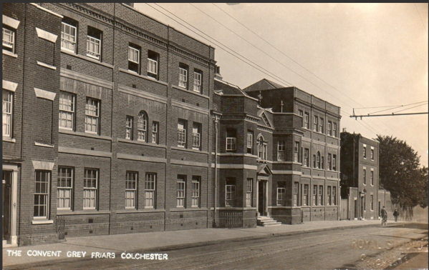
However, I intended to attend the day on June 14th 2024, and put aside 3 things to take with slight mysteries – a waterproof rain cape – by Mary Quant, an elegant walking stick with a hollow interior hidden by a silver cap which contained a measuring rod marked in hands (4 inches) to measure the height of a horse, and a Parker 51 capsule pen produced in 1941(for making notes on the day) and found down the back of a seat in my secondhand car. It was an innovation at the time because at school we were still writing with ‘dip in the ink’ pens. Unfortunately, at the time I could not attend the Antiques Roadshow, so I will never know the reaction.

But when the Antiques Roadshow reaches its half century in 2027 – and that will have been a lot of television programmes to have watched - it will have been a fitting last chapter in my story because Firstsite, near the former Lewis Gardens, is almost opposite Grey Friars (right) the beautiful 1755 building with its former pieces of old CCHS furniture, early writing equipment, school desks, horse-drawn garden implements and 400 year old Holmoak, all of which helped to establish my childhood love of everything old and antique. I now own that old desk, with its ceramic inkwell, which I first sat at so many decades ago. It has pride of place in the garden study, having been saved by me from inevitable destruction during the several changes of function which Grey Friars has experienced over the years.

My Journey Into Botanic Drawing:- (Brenda Green, CCHS 58- 65)

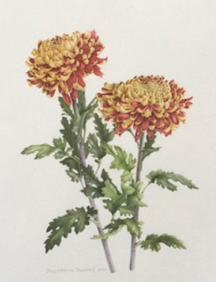
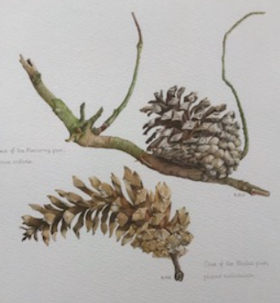
I wondered if any of you would be interested in the above ‘Talk’ I do regarding my becoming a member of The Society of Botanic Artists? When I suggested this to Jean she said we could at least ask and see what response there is. So here goes….

It began, of course, thanks to Molly Brown’s excellent tuition, her Art Room being my one salvation at CCHS, and she certainly gave me good advice then with my drawing techniques. However, my journey to become a Botanic Artist did not occur until many years later, but some important seeds were there ready to nurture, thanks to her!

I bring some examples of my work, and the array of coloured pencils, paper and other equipment I use to carry out my work, with some poetry thrown in for good measure! At the end, if time allows, I give an opportunity to those who would like to try using the coloured pencils for themselves, but don’t worry, drawing skills are NOT necessarily required!

Depending on your response, I may need to hire a venue for a morning or afternoon as I don’t have suitable accommodation in my own home, and that I would have to factor into the cost.

I look forward to hearing from you if you are interested. Please contact me direct by e-mail:-

brendaart@brenm.plus.com or Mob: 07484708134 or Landline 01206 271019 and I will pass on the results to Jean, our Events Organiser.

SCHOOL MAGAZINE 50 YEARS AGO
OGA REPORT FROM SCHOOL MAGAZINE 1974-5 Hilary Motson (Dowrick) Hon Sec

Our Winter Meeting was held on Saturday 25th January 1975. We were very pleased to be well entertained by another excellent Staff Pantomime, Bluebeard, and to meet again so many members of Staff at supper afterwards. The Annual General Meeting was held on Friday 11th July 1975. The weather was kind and a croquet tournament was enjoyed both by competitors and spectators and finally won by Tina Powell(!) . After the Business meeting Mrs Parsonson gave an interesting and amusing talk about her year as Mayoress.

SCHOOL MAGAZINE 75 YEARS AGO

Extracts from the Devil’s Log Book, 1950 – R Munson (Upper VI)

March 10th - All the escalators to “Hell Proper” broke today, and the refrigerators refused to work – climate does not suit them.
April 1st – Set examination papers for entrance to Tempters’ League. All devils passing this exam must wear black woolly stockings for two months in the hottest season.
April 14th – Interviewed several new recruits for the Tempters’ League this morning – all rejected. Scranning worm seems to be slackening in his recruit work. Reprimanded him for neglect of duty.
May 13th – got my new false teeth from the Devilment of Denti-fractures – two sizes too big.
June 5th – Dispatched a devil on a night mare to a victim taking Higher School Certificate. Sent a battalion of junior devils on night ponies to the humans taking school examinations, to remind them of our motto, “Make play while the sun shines”.
June 15th – new detachable tail arrived this morning. Sent old one to be “permed”.
July 7th – Strike reported in Nether Region. Strikers demanding higher wages for overtime.
July 9th – Met delegates from Stokers’ Union. Promised them the next consignment from the Stratosphere to help them in their arduous task.
July 21st – Pleasing report fom Temptress dispatched to CCHS. Many conquests made. Learned of one, RBM, who disobeys constantly repeated commands to come to me. Must visit her myself on the evening prior to the publication of Higher School Certificate results.

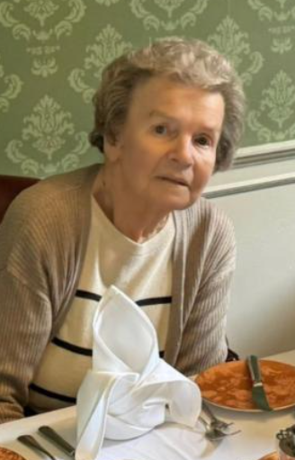
FROM THE COLCHESTER GAZETTE 15TH JANUARY 2025

A former County High School for Girls pupil has returned to the halls she walked as a youngster after a care home made her wish come true. Dorothy Cornell, 87, a resident at Woodland View Care Home on Turner Rise, wanted to return to the former home of the school, in East Hill, which is now Greyfriars. Thanks to the care home’s new Woodland View Wishes initiative her dream that one day she would be back in the same halls has come true.

On a recent trip to Colchester Castle, Dorothy had looked at the hotel and reminisced about her school days. She said: “I’d love to go and see it again, but look how posh it is. I’d never be able to go in there now.” Petra Hardman, activities coordinator at Woodland View, was moved by Dorothy’s words and set out to make it happen.

After a heartfelt conversation with GreyFriars hotel staff Jemma Mitchell, the hotel warmly invited Dorothy for a complimentary afternoon tea and guided tour. Dorothy, accompanied by her daughter Theresa Willsher and granddaughter Sophie Britts, was thrilled to retrace her steps through what were once her school’s classrooms and dining rooms. Guided by kind staff from GreyFriars, Dorothy explored the building, piecing together how the spaces had transformed over the years. She even enjoyed tea in the former headmistress’s office, a moment that brought a flood of memories. “It was wonderful to see her so happy,” said Petra. “She couldn’t believe it was happening.” Dorothy’s family was equally amazed, especially given how vivid her memories of her school days were, despite her recent struggles with memory loss. The afternoon was full of smiles, laughter, and reminiscing, with Dorothy marvelling at the changes and sharing stories about the strict headmistress and how East Hill looked in her youth.

Woodland View’s "Wishes" initiative aims to bring moments of joy to its 60 residents, with plans already in place to fulfil more dreams. Petra added: “Whether it’s helping someone see the West End or ride a motorbike, we’d love to make all these wishes come true.”

FROM THE COLCHESTER GAZETTE AND ESSEX COUNTY STANDARD

Jack Petchey Achievement Award winners


Monica Malagala, 13, (left) from Colchester County High School for Girls, was recognised for her positive and supportive attitude. She set a new championship record in shot put at the Essex School Athletics Championships.

The winners were acknowledged for their extraordinary achievements and their contributions to their schools, colleges, or clubs. Each winner received a medallion, a framed certificate, and a £300 grant to be used to benefit their school or youth group. Councillor Lesley Scott-Boutell, mayor of the city of Colchester, who presented the awards, said: "It is so important that all the outstanding work that our young people are doing, however small, is seen and recognised and that a thank you is given."

The Jack Petchey Foundation has invested more than £699,000 in Colchester since funding began.
CCHS 92% HAPPINESS SCORE

ESSEX'S state secondary schools have been ranked by their happiness with Colchester County High School for Girls ranked joint 13th with a satisfaction or happiness rate of 92 per cent. The Sunday Times has made a list of Ofsted's Parent View analysis between 2020 and 2025, parents fill out surveys about their children's schools, to rank the schools with the highest parental satisfaction. The Sunday Times chose the year in which the largest number of surveys had been completed, typically the year of the school's Ofsted inspection. It also only chose schools with at least 500 places and 100 parents in a single year meaning 1,934 state secondary schools in England and Wales were excluded from the list. CCHS Associate Principal Mrs Frost said: “To ensure strong relationships with parents, we prioritise open communication, regular feedback, and community involvement, creating a strong partnership and cohesion that benefits our students' education and wellbeing”. "We would like to thank our staff and our governors for their belief in the value of the broad, innovative and ambitious curriculum that CCHSG provides, and we are very grateful to our parents and carers for their unrelenting support, which has always been fundamental to our success.

NEWS FROM THE SCHOOL
Thanks to Kate Stubbs, Marketing and Communications Manager

National European Youth Parliament Competition
Congratulations to the CCHSG Year 12 team who have made it through to the National European Youth Parliament Competition in Liverpool in July. EYP supports the development of young people into politically aware and responsible citizens by involving them in European political thinking and promoting intercultural understanding. The European Youth Parliament is one of Europe’s largest youth platforms for civic education, intercultural encounters, and the exchange of ideas. EYP is represented in 40 countries across Europe and around 25,000 young people take part in EYP events every year. The national competition involves working as a team to create a resolution to an issue they have chosen. Delegates then take part in a general assembly where they debate the session’s resolutions. Participants are judged on teamwork, ambassadorial qualities, development, and participation. The best school teams from each National Session are selected to represent the United Kingdom at International Sessions and Forums, held across the entire EYP network.

Chisola Chitambala from “The Apprentice” visits CCHSG by Nora Leugue-Yomba, Year 11

Students from Years 9 to 13 had the incredible opportunity to attend an inspiring talk by “The Apprentice” contestant Chisola Chitambala. She shared her remarkable journey, from struggling with her A levels to becoming a children’s nurse and eventually stepping into the world of business. Her story was one of resilience, determination, and self-belief, showing us that setbacks do not define our future. Instead, she encouraged us to view failures as stepping stones to success, reminding us that perseverance and hard work can lead to incredible opportunities.

“One of the key things I hope to prove to myself is my ability to consistently step outside my comfort zone and thrive in unfamiliar and challenging business situations. I want to demonstrate that I can navigate uncertainty with confidence, tackling tasks head-on even when the path forward isn’t immediately clear.”

During the session, we had the chance to ask Chisola questions about her experiences, including how she stayed motivated when things didn’t go as planned. She spoke openly about the challenges she faced and the lessons she learned along the way, offering valuable advice about school, career choices, and life in general. Her words resonated with many of us, particularly her emphasis on believing in ourselves and never letting fear hold us back. The talk left us feeling empowered and motivated to take control of our own futures, knowing that setbacks are just part of the journey. We are incredibly grateful to Chisola for sharing her story with such honesty and encouragement. Remember the words of Walt Disney: “The way to get started is to quit talking and begin doing”. A huge thank you also goes to Mrs. Knight for organizing this amazing experience—we all left feeling truly inspired!

A Week at LSEG: Insightful Work Experience

During last half term holiday, two of our A Level Economics students, Millie McLean and Anuji Madanayake, were given the incredible opportunity of spending a week on work experience at the London Stock Exchange Group (LSEG). This prestigious organisation is a leading global financial markets infrastructure and data provider that operates connected businesses to serve customers across the entire financial markets chain. The students gained valuable insights into the world of finance, trading, and market operations. Throughout the week, Millie and Anuji were immersed in a range of activities that helped them understand the complexities of financial markets. They had the chance to work alongside professionals in various departments, from market analysis to risk management, and participated in real-world discussions about economic trends and the impact of financial decisions on both a local and global scale. One of the highlights of their time at LSEG was shadowing a team of market analysts who gave them an insider’s perspective on how data is used to predict market movements. They also learned about the role of stock exchanges in global trade, the importance of financial regulation, and how technology is transforming the financial industry.

Both Millie and Anuji were particularly fascinated by the high-stakes environment of the trading floor and the fast-paced nature of decision-making in the financial world. The experience also allowed them to see how their classroom knowledge in economics could be applied in real-life scenarios, reinforcing their passion for the subject and sparking an interest in pursuing finance-related careers.

Reflecting on the experience, Millie said, "It was an eye-opening week that gave me a deeper understanding of how markets function and the economic forces at play. I’m excited to bring back the insights I’ve gained into my studies and future career plans."

Anuji shared, "The opportunity to work alongside experts in the field was invaluable. It really made me appreciate the depth of knowledge and skills required to thrive in the financial sector."

Both Millie and Anuji are grateful for the experience and would like to thank LSEG for the opportunity to learn in such a dynamic environment. We look forward to seeing how their work experience will influence their future academic and career aspirations.

Evening of Languages

At CCHSG we are proud to have students speaking over 40 languages including Irish, French, German, Spanish, Hungarian, Dutch/Flemish, Italian, Greek, Turkish, Kurdish, Farsi/Persian, Arabic, Mauritian Creole, Tamil, Malayalam, Hindi, Urdu, Telugu, Gujarati, Bengali, Nepali, Sinhala, Burmese, Vietnamese, Cantonese, Hong Kong Chinese, Mandarin, Korean, Japanese, Igbo, Yoruba and Chichewa. Cultures and traditions emanate from the four corners of the world. Students celebrated with an evening showcasing linguistic and cultural diversity. Acts included: Year 13 Rock Band, Year 12 French Students, Les Cancannettes, Les Choristes de Year 7, Chinese Club, South Asian Society, Afro-Caribbean Society, German Club, Spanish Club and K-Pop Dance Club alongside other solo and group performances. We thank all the staff involved. Particular thanks go to our language assistants who worked with the groups and Mme Ollite, who co-ordinated the show.

Crime Scene Forensics in A level Psychology

Year 13 Psychology students were met by POLICE DO NOT CROSS tape for an afternoon of crime solving in a re-construction of a crime scene in G23. Mrs Phillips guided each class step by step to explore what it could be like as a Forensic Investigator to put learning into practice as part of the A Level Psychology specification. Forensic psychology is about the psychology of crime. This A Level psychology topic looks at explanations of why people commit crimes, ways of using psychology to catch criminals, and the psychology of punishing crime and preventing criminals from reoffending:

· Offender profiling
· Biological explanations of criminal behaviour (including genes, and neural factors)
· Psychological explanations of criminal behaviour
· Dealing with criminal behaviour (including custodial sentencing, behaviour modification, anger management, and restorative justice)

Here are some quotes from the Year 13s explaining their experience of the role play during their practical lesson activity as the crime unfolded:

“Together we led an investigation into the murder of Deid Mann. Confronted with the crime scene, we collected forensic evidence such as DNA samples and matched fingerprints to our suspects. After interviewing a range of suspects and collecting qualitative data, we were successfully led to the motive of the crime, and correctly identified the murderer.” Lilly Pedder (Lead Inspector)

“It was a great experience in learning how forensic psychologists would handle evidence and analyse them! Having the chance to interview witnesses meant that we could practice techniques (like recreating the scene by asking them to describe what the party was like) and by working as a group, we could split up into gathering information from the scene and from the testimonies. It taught me that (if there is a next time) using the ‘top-down’ approach might be better in creating a profile for the killer, such as who was most likely to create a disorganised crime scene.” Ayur Kelzang (Lead Inspector)

“As the forensic pathologist, I was responsible for collecting the evidence gathered from the police detectives and analysing it to see if we could gather clues from the crime scene. It was interesting to see all the ways evidence could be collected and processed, from fingerprint analysis to the autopsy report, as more aspects of the crime began to unravel.” Irede Okubadejoi (Forensic Pathologist)

“My crime was displayed to the class and they had to use forensic psychology knowledge to interview me and use the clues to trace the crime back to me. They had to avoid my genius red herrings and analyse evidence efficiently to solve the case.” Maddie Strevens (The Murderer)

Owen Teale Visits CCHSG
On the 28 February, Owen Teale, best known for his role as Alliser Thorne in TV show Game of Thrones came to CCHSG to talk to our English Literature A Level students. One of our topics in English covers the play “A Doll’s House” by Henrik Ibsen, published in 1879. Owen Teale played one of the main characters, Torvald Helmer in Anthony Page’s 1996 production of “A Doll’s House” which debuted in the West End and then progressed onto Broadway in April of 1997. For this role, Teale won a Tony Award for Best Featured Actor in a Play. He gave us insights into how he developed the character of Torvald, while also sharing funny stories of productions and his own thoughts and feelings about the play itself as well as its characters.

Students had the opportunity to ask questions about his experiences and he responded with very thoughtful answers, expressing his interest in our studies. We had many interesting topics of discussion, one of which was debating whether Kristine was in the wrong for allowing Helmer to find out about the forgery, when Nora had been nothing but a good friend to her. His insight gave us all some good critical quotes for the character of Helmer, while also allowing us to understand the character more in depth. Special thanks go to Miss Watling for organising this opportunity.

The CCHSG e-Newsletter is published every half term and can be found on the website www.cchsg.com under “news” or via https://www.cchsg.com/news/enewsletter/

EVENTS – Jean Johnson, Treasurer & Events Organiser

Our year started in February when a group of us went for coffee at the Officers’ Club in Colchester and following on from that first occasion we have a full programme for the rest of the year.

Saturday 12th April: we will meet again at the Crown Public House in Lexden Road for breakfast. Arrive 10am. This occasion may well have taken place before the newsletter is received so I will be telephoning everyone who has attended in the past to let them know. I do need to know how many members intend to come, so the Manager can arrange the seating accordingly. For this breakfast everyone orders their choice and pays individually. My contact details are at the end of this page.

Wednesday 14th May: Lunch at the Chinese Restaurant, Bamboo House in Military Road. £20 including coffee if required. Other drinks to be paid for individually on the day. Arrive 12.30pm

Thursday 26th June: Meet at Greyfriars at 10.30am. On this occasion we will gather on the terrace, weather permitting, and everyone will order and pay for coffee, etc, for themselves. It’s not the usual Coffee morning at Greyfriars, so no money required in advance. However, as a courtesy to Greyfriars I would like to give them an approximate number attending, so please contact me during the week before if you intend to come.

Tuesday 22nd July: Coffee with Jean, Mary and Gregg, at my house, 10 Landseer Road Colchester CO3 4 QR. 10am – noon. £7. If you need information about bus routes please contact me. It is possible to park in the road nearby but be aware of the yellow line restrictions.

Thursday 21st August: The annual Garden Party at Liz’s house, 187 Lexden Road, Colchester, CO3 3TE
  - -5pm.

Saturday 6th September: A later in the year than usual Annual General Meeting at the School. Cost if you stay to lunch £12. If you only have time for coffee on arrival please send cheque for only £2.50. We are grateful to the School for allowing us to have our AGM on the premises but this year our booking is time-limited. Arrive for coffee at 10.30am, but please note we will have an early lunch so as to vacate the school by 2pm.

Thursday 16th October: Coffee at Greyfriars as usual. Cost £11. 10am to noon.

We hope that we will have a good response to this full programme.

My address for the reply slips is 10 Landseer Road, Colchester, CO3 4QR

My contact details for when required are tel: 01206 579688. Mobile 07799 525245
Email – jeanjons@btinternet.com

Breakfast at Crown Inn Lexden 9 Nov 24
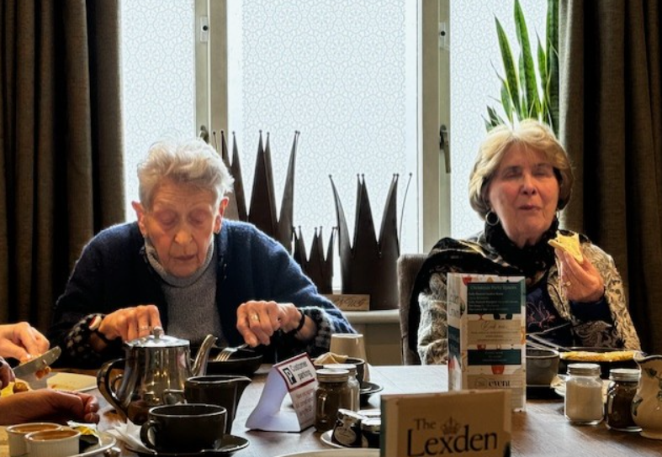
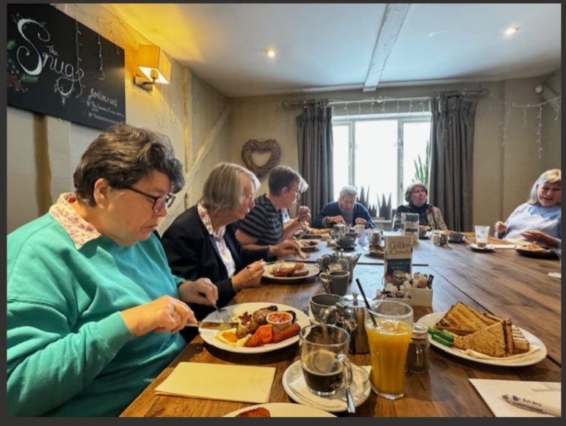

Coffee Morning Officers’ Club – 25th February 2025





